Improving an Industrial Problem Associated with Optimizing Material in Car Seats
Alberto Ochoa-Zezzatti¹, Jöns Sánchez², Alberto Hernández-Aguilar³ & Ricardo Pérez⁴
¹Juarez City University
²Instituto Tecnológico de Querétaro -Campus Querétaro-
³Universidad Autónoma del Estado de Morelos
⁴CIMAT (Centro de Investigación en Matemáticas)

Abstract. In the present study explains the design of an intelligent system based on bio-inspired algorithm as an aid in the strategic planning to improve the disminution of reduced wastage associated with cutting parts of the seat covering, unlike current applications, is focused on an environment that goes beyond simple numerical forecasts and statistical processes to make this job shop. It is based on an advanced algorithm named “Bat Algorithm” that optimizes the strategies to be followed within the cut process, helping with the correct decision support to achieve competitive advantage in the market. This proposed model associated with Bioinspired Algorithm is flexible, adaptive, has learning ability, is robust and fault tolerant. This proposed model is based on methodology associated with Bioinspired Algorithms which provides optimal strategies to improve competitiveness in a company, the ability of the model can provide strategies that are not obvious because they can find no obvious relationships among variables can help the manager or leader of a company. This tool is an aid in the process of improving competitiveness because it supports the strategic decisions made in administrative technology levels of the companies. Keywords: Strategic Planning, Decision Support System, Bioinspired algorithm.

1. Introduction
Mexico has one of the most developed manufacturing sectors in Latin America. Its importance is that this sector contributes over one fifth of the gross domestic product (GDP), and remains one of the area’s most attractive for foreign investment in the country, because there are sectors of advanced manufacturing with great potential for growth. One of the main advantages that Mexico offers compared to other countries is the presence of production chains in sectors such as automotive, aerospace, and electronics [1].
The automotive industry in Mexico is mature, dynamic and is constantly growing. Despite the decline in growth in 2008, in 2011 it showed clear signs of recovery; light vehicle production reached a new record with 2.55 million vehicles produced. Globally, Mexico is ranked as the eighth largest producer of light vehicles. It should be noted that in two years. Mexico climbed two positions, leaving the production of France and Spain as in analyzed in: [2].
Currently, this sector accounts for 4% of national GDP and 20% of the production of the manufacturing industry. Nowadays, consumers doesn't only focus on acquiring luxury cars with exterior and powerful, but also those who are inclined seats have high quality, unique, refined, comfortable and safe styles; so to meet these new needs have worked on innovation of certain components associated with car seats, among which are the seats with ventilation, heating, clothes microfibre and leather, airbags and adjustments Customizable. Based on the above technological development and innovation in the automotive industry it has focused on the generation of new designs not only abroad, but has given more importance to the interior of a vehicle, as is shown in Figure 1.
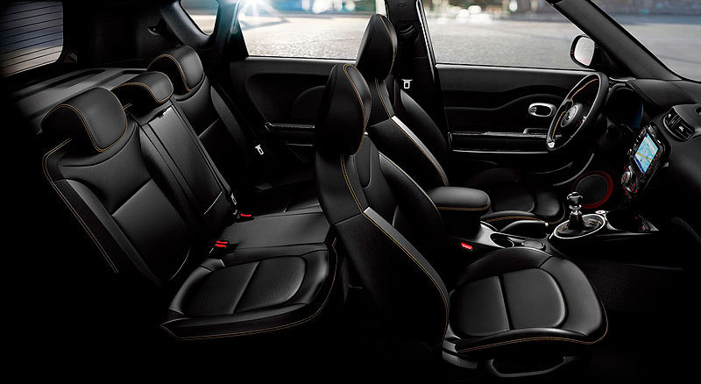
Figure 1. Interior of a car with its design of coatings in the seats.
Because the number of components that make up a car, this is regarded as a technologically complex system [3]. Particularly, because each of the components has been designed and manufactured according to certain specifications in material and dimensions.
Unlike other industries, the development of the automotive industry converges various areas of knowledge and technology, such as engineering, electrical, electronics, mechanics, computer science, robotics, chemistry and materials development. Each of the discipline is applied to the subsystems in the results, such as the engine, transmiión, steering, suspension, bodywork, brakes, wheels, electrical system and the garments, among others. Each subsystem performs a specific function and interacts with the other subsystems for optimum performance of the car [3].
In turn inside of a vehicle it consists of a set of subsystems and today represents a large investment of labour and resources in innovation and technological development. The interior system consists of individual modules such as the seats, doors and interior finishes, the board (cockpit) and top or ceiling (overhead systems), Table 1 shows the parts that make up the inside shows a car. In turn, each module consists of various parts that use different technologies, some of which are simple to manufacture, but some others can become extremely complex to the point of being considered subsystems themselves One of these subsystems are the seats.
It is well known that the design of the cockpit of a car has changed since the famous Model T Ford, which had a booth which was made up of only a box without seats, which were crude and cumbersome. However, the concept of internal suffered material from the 60s instead suecdió this change along with the increase of engine power and fuel efficiency, these changes, in turn, generated a duration combine travel, and thanks to the inner comodiad, the said period increased, which in turn incrmeneto fatal accidents on the roads.
Also, increasing competition increased the need for manufacturers to innovate not only abroad not only on the outside and the engine of the vehicle [4] but began to pay greater attention to the interior, which includes not only the board and the system of meaning, but also the seats and their garments [3].

Table 1. Components of a car, including car’s seats.
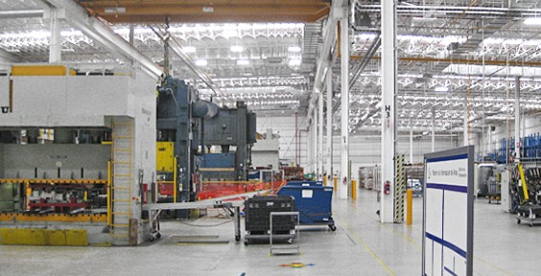
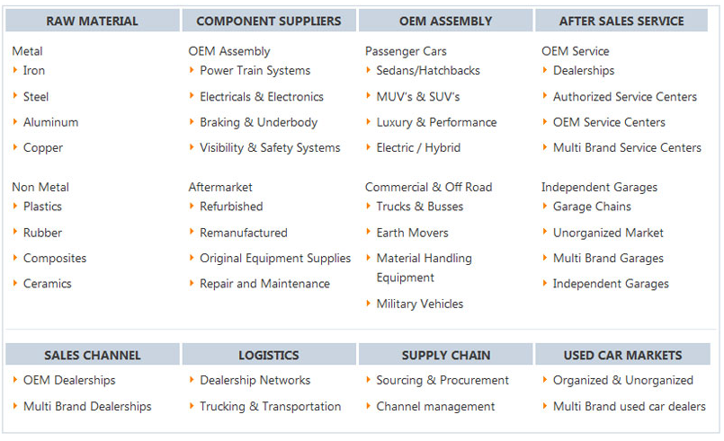
2. Defining problem to be solved: Optimizing wardrobe of a seat and decreasing its loss in the cut
The handling of materials that make up the garment of the seats, like skins which are used in luxury sports cars and require high accuracy to meet the quality required by clients of such cars.
Currently the globalization of markets has caused manufacturing processes are in intense competition, forcing companies to seek and implement strategies to be competitive. Quality requirements have increased competition in the automotive sector. Therefore, it is necessary to optimize all the processes involved in producing such a way that the results allow offering the highest quality at the lowest cost.
The drilling process is directly related to the quality of the finished garments, seat of luxury vehicles produced by the company Lear, which was conducted this investigation. Why this paper seeks to optimize this process, decreasing the percentage of defects in parts per million (PPMs), as the major defects already mentioned is in the heterogeneity of the separation of drilling, this due to the advancement of the paper web in which the material being drilled is supported. This heterogeneity decreases quality and increases waste that result in a loss for the company, this research aims to reduce defects of parts.
Continuous improvement and innovation.
Continuous improvement means making effective changes, results manage and improve processes, identifying causes or restrictions, establishing theories improvement, carrying out plans, studies and obtaining the results and standardizing the positive effects to project in addition to the permanent pursuit of personal and working groups that impact the results. Through establishing better ways of working and performance.
Innovation refers to the radical change in the way of doing things related to a system or process (quantum leap), the most common conditions for recourse to innovation happen when: a) the system or process is not effective, b) is obsolete, or c) when the group that administers the system or process discovers an advanced way the job [5].
The term "continuous improvement" means incremental changes, which are small and gradual, as the radical improvements that are both significant and rapid. These improvements may take one of several forms:
- Increase customer value with new and better products and services.
- Reduce errors, defects, waste and related costs.
- Increase productivity and efficiency in the use of all resources.
- Improve the responsiveness and performance of the cycle time for processes such as attention to customer complaints or the introduction of new products [6].
In less formal terms, quality, customer-defined, is the judgment that it has about a product or service. A customer is dissatisfied when offered everything he hoped to find and more. Therefore, quality is above all customer satisfaction, which is linked to the expectations that it has with respect to the product or service [7].
3. Proposal Methodology
3.1 Bat Algorithm

This is a Bio-inspired algorithm of recently created, was proposed by Yang in 2010 [8]. The bats are animals and their advanced capability to move in the dark due to a system of echolocation. This System works as a type of sonar: bats emit a loud and short pulse of sound, wait it hits into an object and, after a fraction of time, the echo returns back to their ears [9], with this action they can identify objects. Thus, bats can compute how far they are from a specific object, to take action during his flight over the speed and direction it should take [10]. In addition, this amazing orientation mechanism makes bats being able to distinguish the difference between an obstacle and a prey, allowing them to hunt even in complete darkness [11]. The Bat Algorithm, such technique has been developed to behave as a band of bats tracking prey/foods using their capability of echolocation. In order to model this algorithm, Yang described some rules that are basic for the algorithm, as follows:
1) All bats use echolocation to sense distance, and they also “know” the difference between food/prey and background barriers in some magical way;
2) A bat 𝑏𝑖 fly randomly with velocity 𝑣𝑖 at position 𝑥𝑖 with a fixed frequency 𝑓min, varying wavelength 𝜆 and loudness 𝐴0 to search for prey. They can automatically adjust the wavelength (or frequency) of their emitted pulses and adjust the rate of pulse emission 𝑟 ∈ [0, 1], depending on the proximity of their target;
3) Although the loudness can vary in many ways, Yang assumes that the loudness varies from a large (positive) 𝐴0 to a minimum constant value 𝐴𝑚𝑖𝑛.

3.2 Bat Algorithm Description

First, are initialized the initial position 𝑥𝑖 for each bat 𝑏𝑖, with his velocity 𝑣𝑖 and frequency 𝑓𝑖. For each time step 𝑡, being 𝑇 the maximum number of iterations, the movement of the virtual bats is given by updating their velocity and position using Equations 1, 2 and 3, as follows:
𝑓𝑖 = 𝑓min + (𝑓min − 𝑓max)𝛽, (1)
𝑣𝑗𝑖 (𝑡) = 𝑣𝑗𝑖 (𝑡 − 1) + [ˆ𝑥𝑗 − 𝑥𝑗𝑖 (𝑡 − 1)]𝑓𝑖, (2)
𝑥𝑗𝑖 (𝑡) = 𝑥𝑗𝑖 (𝑡 − 1) + 𝑣𝑗𝑖 (𝑡), (3)
𝛽 is a normalized number randomly generated within the interval [0, 1], 𝑥𝑗𝑖 (𝑡) denotes the value of decision variable 𝑗 for bat 𝑖 at time 𝑡. The result of 𝑓𝑖 (Equation 1) is used to control the pace and range of the movement of the bats. The variable ˆ𝑥𝑗 represents the current global best location (solution) for decision variable 𝑗, which is achieved comparing all the solutions provided by the 𝑚 bats. In order to improve the variety of the possible solutions, Yang has proposed to employ random walks. Primarily, one solution is selected among the current best solutions, and then the random walk is applied in order to generate a new solution for each bat that accepts the condition in Line 5 of the algorithm:
𝑥𝑛𝑒𝑤 = 𝑥𝑜𝑙𝑑 + 𝜖𝐴(𝑡), (4)
in which 𝐴(𝑡) stands for the average loudness of all the bats at time 𝑡, and 𝜖 ∈ [−1, 1] attempts to the direction and strength of the random walk. Whereby for each one iteration in the algorithm, the loudness 𝐴𝑖 and the emission pulse rate 𝑟𝑖 are updated, as follows:
𝐴𝑖(𝑡 + 1) = 𝛼𝐴𝑖(𝑡) (5) and
𝑟𝑖(𝑡 + 1) = 𝑟𝑖(0)[1 − 𝑒𝑥𝑝(−𝛾𝑡)], (6)
where 𝛼 and 𝛾 are ad-hoc constants. At the first step of the algorithm, the emission rate 𝑟𝑖(0) and the loudness 𝐴𝑖(0) are often randomly chosen. Generally, 𝐴𝑖(0) ∈ [1, 2] and 𝑟𝑖(0) ∈ [0, 1].

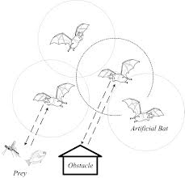
Algorithm 1. – BAT ALGORITHM
Objective function 𝑓(𝑥), 𝑥 = (𝑥1, ..., 𝑥𝑛).
Initialize the bat population 𝑥𝑖 and 𝑣𝑖, 𝑖 = 1, 2, ...,𝑚.
Define pulse frequency 𝑓𝑖 at 𝑥𝑖, ∀𝑖 = 1, 2, . . . , 𝑚.
Initialize pulse rates 𝑟𝑖 and the loudness 𝐴𝑖, 𝑖 = 1, 2, . . , 𝑚.
1. While 𝑡 < 𝑇
2. For each bat 𝑏𝑖, do
3. Generate new solutions through Equations (1), (2) and (3).
4. If 𝑟𝑎𝑛𝑑 > 𝑟𝑖, then
5. Select a solution among the best solutions.
6. Generate a local solution around the best solution.
7. If 𝑟𝑎𝑛𝑑 < 𝐴𝑖 and 𝑓(𝑥𝑖) < 𝑓(ˆ𝑥), then
8. Accept the new solutions.
9. Increase 𝑟𝑖 and reduce 𝐴𝑖.
10. Rank the bats and find the current best ˆ𝑥.

4. Design of Experiments
In the field of industry often do experiments or tests in an attempt to solve a problem or test an idea (conjecture, hypothesis); for example, make some changes in materials, methods or operating conditions of a process, test various temperatures in a machine until you find the one that gives the best result or create a new material with the intention of achieving improvements or eliminate any problems [12].
However, it is common that these tests or experiments are made on the fly, based on trial and error, by appealing to the experience and intuition, rather than following a suitable experimental plan to ensure a good response to the questions raised. Something similar happens with the experienced data analysis, where more than rigorous analyses of all the information obtained and consider an informal variation analysis is done, "intuitive". Such is the power of experimentation that sometimes, improvements are achieved even though the experiment was based on trial and error. However, in situations of any complexity it is not enough to apply this type of experimentation, so it is always best to proceed in an efficient way that ensures obtaining the answers to the questions raised in a short period of time and using fewer resources.
The statistical design of experiments is precisely the most effective way of testing. The design of experiments is to determine which tests should be done and how to obtain data that, when analyzed statistically, provide objective evidence to answer the questions raised, and thus clarify the uncertain aspects of a process, resolve a problem or improvements therein.

Factorial Design
The factorial experimental design is critical and is basically an experimental strategy in which the factors are varied together, rather than one at a time, so that allows to study the individual effect and interaction of two or more input factors (X) on one or more variables of response / output (Y). There are different types of factorial design. Some of the most common are fractional factorial, factorial design 2², 2³, 2⁴, 2^{K} and to adjust the number of runs at less than the original number and that is consistent with the desired amount of experience due to time or resources. In any factorial the number found in place of the exponent represents the number of factors of interest in the experiment and that is on the base representing the levels at which it will vary factors of interest [12].
Factors
Factors may be qualitative (machines, material type, operator, the presence or absence of a previous operation etc.), or quantitative (temperature, humidity, velocity, pressure, in another’s). When any of the other factors are responsible of influence a response variable can be classified as potential factors in the design or interfering factors. Potential design factors are those that the experimenter may want to vary in the experiment. Moreover, the disturbing factors can have significant effects to be taken into consideration, that although no interest in them within the context of the experiment.
4.1 Main effect and interaction effect
The effect of a factor is defined as the observed change in the response variable due to a change in the level of such factor. In particular, the main effects are changes in the average of the response variable are due to the individual action of each factor. In mathematical terms, the main effect of a factor two difference between the levels is obtained when the factor was in the second level, for example, for the data of Table 3, the main effects mean response are given by:
Effect A = 41+45 – 28+63 = -2.5
2 2
Effect B = 63+45 – 28+41 = 19.5
2 2

So in absolute terms, the main effect of B is greater. Moreover, it is said that two factors interact or have an interaction effect between the response variable when the effect of a factor depends on the level that is the other.
A robust design is an experiment in which there are noise factors (uncontrollable) considered explicitly or implicitly, the effect of which is to minimize indirectly (IE without controlling it directly), to find the combination of levels yes process factors can be controlled, and wherein the effect of said factors noise is minimal. In other words, in a robust experiment it is to make the product / process to the desired without being affected the uncontrolled sources of variation performance. The main objective of a robust design is to determine the combination of levels of the controllable factors, where no noise factors affect the process, although the latter are not controlled. The meaning of the word is robust in the sense of making the process or insensitive or resistant to noise factors product that is not in our hands to control.
4.2 Results of our Bioinspired Algorithm
The results obtained from the drilled offset processed parts during the experiment varied from a minimum of 4.9479 mm to 5.7863 mm maximum obtaining an average value of 5.2500 mm with a standard deviation of +/- -2431 mm Table 2 shows the value obtained by the combination conducted and using our bioinspirade algorithm. Figure 2 shows a different solution for reducing loss of material using our bio-inspired and only factor analysis algorithm. Using our model based on a Bioinspired Algorithm can reduce to 43% the material is wasted, whereas if only it had conducted a factor analysis model had achieved only 17%, this is mainly because mathematically cannot explore the search space and compare values detected in different parts of the Pareto front and then combine them to achieve a solution hybrid according to the required solution.
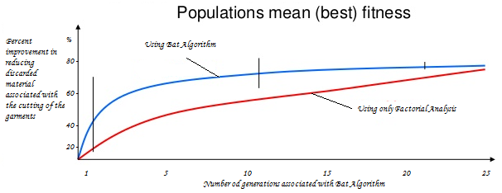
Figure 2. Comparison of appropriate bio-inspired tuning our algorithm to properly reduce wasted material.
To explain in more detail the behaviour generated in Figure 2, use a design of experiments according to a set of situations present the problem of reducing waste in the production of seats, so in order to determine the stability of cutting optimization seat (exact cuts) are made in cutting machines for a week, 3 different cutting shapes, 3 different times for completion, tested latter refers to the number of days that elapse the cut is made until it is subjected to quality analysis with the test to be performed. The information was collected from 4 different samples from 4 different operators who made the cuts. The results expressed in millimetres of waste per piece are presented below and presented in specific data in Table 2:
Factor M: (Cutting Machine style): M₁, M₂, M₃
Factor T: (Time, Days): T₁ (3 days), T₂ (5 days), T₃ (7 days)
Blocks (Operators): B1, B2, B3, B4

Table 2. Description of components in the design of experiments proposed.
 |  | M1 |  |  | M2 |  |  | M3
BLOQ | T1 | T2 | T3 | T1 | T2 | T3 | T1 | T2 | T3 | Total
1 | 7.51 | 8.00 | 7.50 | 7.06 | 6.97 | 6.86 | 6.10 | 7.03 | 6.93 | 63.96
2 | 7.74 | 6.86 | 7.43 | 7.03 | 6.29 | 6.71 | 6.97 | 6.29 | 6.20 | 61.51
3 | 7.11 | 7.09 | 7.40 | 6.11 | 6.29 | 6.89 | 5.77 | 6.00 | 6.46 | 59.11
4 | 6.64 | 6.91 | 7.66 | 7.60 | 6.06 | 7.09 | 6.80 | 6.17 | 6.80 | 61.73
Total | 29.01 | 28.86 | 29.99 | 27.80 | 25.60 | 27.54 | 25.64 | 25.49 | 26.39 | 246.31
 | M1=87.86 |  |  | M2=80.94 |  |  | M3=77.51
 | T1=82.46 |  |  | T2=79.94 |  |  | T3=83.91
Where:
I: 1, 2, 3 (Cutting Machine style) j: 1, 2, 3 (Time) k: 1, 2, 3, 4 (Operator)
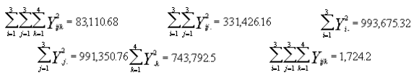
In Table 3, we can see the different components (factors) associated with the cutting process the garments of a car in the auto parts industry. It is noteworthy that the experimental design was improved by using our bioninspirade algorithm to determine the appropriate values associated with the reduction of a factor affecting the cut of the garments and optimize the reduction of waste all depending on the time allotted for garments each car.
Table 3. The results of the tests performed in the experiment-
Factor Levels
Order Speed Paper Speed rolled paper Voltage Paper Radio Result (mm gap)
1 1 1 1 1 0.1943
2 1 1 1 2 0.6122
3 1 1 2 1 0.0266
4 1 1 2 2 0.07
5 1 2 1 1 0.4457
6 1 2 1 2 0.4762
7 1 2 2 1 0.1358
8 1 2 2 2 0.2451
9 2 1 1 1 0.2019
10 2 1 1 2 0.7683
11 2 1 2 1 0
12 2 1 2 2 0.3467
13 2 2 1 1 0.1943
14 2 2 1 2 -0.0521
15 2 2 2 2 0.3416
Average 0.2500
Standard deviation 0.2431
Minimum Value -0.0521
Maximum Value 0.7683

5. Conclusions and Future Work
The design of experiments is a set of techniques that turn out to be a useful tool in the characterization and understanding of the processes and the optimization of its parameters, however, it can also become very complex and iterative so to take out a design of experiments and maximize results or improvements need to invest in resources, materials and time, which in turn, leads to having a lot of coordination, monitoring, disposal and especially commitment to the study by members and other equipment due to totally unexpected situations so with this we must emphasize that much of the success of a DOE is it more robust by implementing a bio-inspired algorithm and coordinate must lie with good planning and organization of experimental work also. Finally, it is important to mention that having as main effects advancement factors used to coat paper and winding the seat thereof, suggests that the vibration that may come to have the machine, due to the speed with which works may be a noise factor in the process and it is recommended to analyse future with the Taguchi philosophy and our bio-inspired algorithm proposed by this hybrid algorithm can provide more information about these types of factors and how to neutralize or diminish them.
In Ciudad Juarez, almost 72% of the manufacturing industry is associated with the development of auto parts, the implementation of different AI techniques will increase the competitiveness of the company, and allow as is happening at this moment that the lack up to 10,000 specialized workers to increase productivity of the industrial sector. Competitiveness is a key to position itself in the global market factor including Cultural Capital in the manufactured business as is proposed by [13], that is why the use of innovative AI techniques allow this in a period not exceeding 20 years, since not only be dependent on the proper interpretation and use technology, but to propose paradigm shifts and use of proprietary technology by implementing efficient models of technology transfer, which is very little researched and implemented in the state of Chihuahua.
References
[1] FUMEC. (22 de Septiembre, 2014), FUMEC:
[2] PROMEXICO (28 de Septiembre, 2014) PROMEXICO. Obtenido de http://www.promexico.gob.mx/en/mx/fortalezas-mexico.
[3] Womack, J.D. (1992). La máquina que cambio el mundo. Madrid, McGrawHill.
[4] Yañez-Zurita, K. A Car-Seat Example of Automated Anthropomorphic Testing of Fabrics Using Force-Controlled Robot Motions. IEEE T. Automation Science and Engineering 8(2): 280-291 (2011).
[5] Carbellido, N. (2005). ¿Qué es la calidad?. Conceptos, guríús y modelos fundamentals. Editorial Limusa, México.
[6] Evans, J.R. (2005). Adminsitración y control de la calidad, Editorial Thomson, México.
[7] Thomson R. (1980). Technology, Government and the future of the Automobile Industry. New York, McGraw Hill Editorial.
[8] Yang. X.-S, “Bat algorithm for multi-objective optimisation,”International Journal of Bio-Inspired Computation, vol. 3, no. 5, pp.267–274,
[9] Griffin D. R., Webster F. A., and Michael C. R., “The echolocation of flying insects by bats,” Animal Behaviour, vol. 8, no. 34, pp. 141 –154, 1960.
[10] Metzner W., “Echolocation behaviour in bats.” Science Progress Edinburgh, vol. 75, no. 298, pp. 453–465, 1991
[11] Schnitzler H.-U. and Kalko E. K. V., “Echolocation by insect-eating bats,” BioScience, vol. 51, no. 7, pp. 557–569, July 2001.
[12] Montgomery, D.C. (2004). Diseño y análisis de experimentos. Editorial Limusa, México.
[13] Lucero, M. (2015) Competitiveness from the perspective of capital factor and influence quality of strategic decision multiculturalism policies. in the Book Financial Modern Applications and Uncertainty Models based on Artificial Intelligence edited by Reijkyavyjk University, Iceland.

